Python run first time
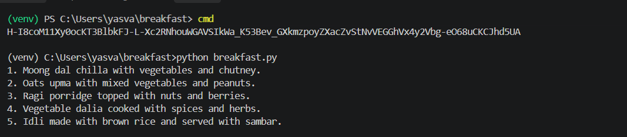
Python Run Second time
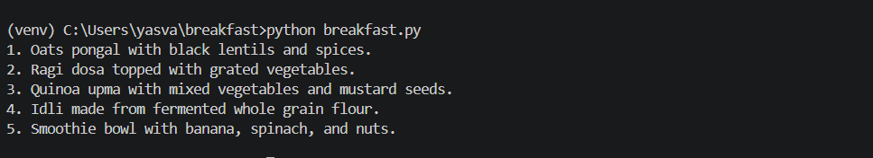
After Changing the code lm = ChatOpenAI(model="gpt-4o-mini", temperature=0) running twice
